## ***Theme*:** **science in human activities and occupations**

## **Topic 9: science at home and in our community**

## **preparation of clean and safe water for drinking and washing, cooking, bathing.**

## ***water***: water is a colourless liquid substance made up of hydrogen and oxygen gas.

## **sources of water**

## **water can be got from many sources like water**;

## rain, artesian wells, ponds, oceans and seas, hot springs, streams, lakes, rivers and swamps.

## **properties of pure water**

## **pure water:** is clean water that has no chemicals in it.

## it is colorless.

## it has no odours (smell).

## it is tasteless.

## pure water boils at 100 degrees celsius ( 212 degrees fahrenheit) and freezes at 0 degrees celsius (32 degrees fahrenheit).

## pure water forms lather (foam) easily with soap.

## it has no suspended matter like dirt.

## **uses of water in the body**

## water makes up part of blood as plasma.

## water helps to dissolve the digested food in the body for easy absorption.

## water maintains the shape of the body cells.

## water cools the body in form of sweat.

## water helps in formation of body fluids like; tears, urine, saliva and sweat.

## **uses of water to the plants**

## water acts as raw materials in plants for photosynthesis process.

## water helps in germination of seeds.

## water cools the plant during transpiration.

## **uses of water to people**

## water is used fordomestic use like cooking, washing etc.

## water is used for drinking in man, animals and birds.

## water is used for irrigation in agriculture.

## it is used in generation of hydro electricity.

## it is used in industries for cooling machines. Mom

## it is used as raw materials in industries.

## **methods of obtaining safe water for drinking**

## **Safe water**: is water that is free from germs.

## **There are two methods/ways of obtaining safe water. these are:**

## by boiling it.

## by treating it with recommend chemicals.

## **Boiling water**

## water is heated using source of heat.

## when water is heated, it boils at a temperature of 100 degrees celsius ( 212 degrees fahrenheit).

## this temperature kills germs from water and become safe for drinking.

## boiling is different from evaporation.

## evaporation takes place at all temperature and it occurs only at the surface.

## boiling takes specific temperature and it occurs throughout the entire liquid.

## after boiling water, should be cooled and kept in clean containers d cover to avoid re-contamination.

## the high temperature during boiling process makes the microorganisms in water die. **Examples of microorganisms;** viruses, bacteria, protozoa etc.

## **Treating water with recommend chemicals.**

## **Treating water**: Is adding chemicals to kill germs in it. **Examples of chemicals used to treat water**; fluorine, chlorine, calcium, chloride, iodine, water guard and aqua safe.

## Piped water is controlled by **National Water and Sewerage Co-operation.**

## The piped water goes through **sedimentation**, **filtration** and **treatment.**

## The main method used to treat piped water is called **chlorination**.

## **chlorination** is the process of adding chlorine in water to kill germs. however, it gets contaminated in the pipe because of leakage.

## **Advantages**

## **of using chemicals to treat water**

## chemical easily kill germs.

## treating of water is quick.

## **Disadvantages of using chemicals to treat water**

## They are expensive to buy chemicals.

## They do not make water clear.

## They add smell and taste to water.

## **Methods of obtaining clean water for washing, cooking, bathing from dirty water**

## **Clean water:** is water that has no dirty and solidified particles in it.

## **There are three ways of obtaining clean water;**

## Filtration method.

## Decantation method.

## Distillation method.

## **Decantation**:

## This is the process of removing solid particles from water after allowing them to settle at the bottom of container.

## When dirty water is allowed to settle, the solid particles will go down at the bottom of container.

## Then clean water on top is poured carefully to a clean container.

## The clean water collected during decantation is called **decants**. The remaining solid particles is called **residues**.

## **The three pot system of decantation**

## **Step one:** A mixture of solid particles and water is put in pot and allowed to settle for some time.

**Step two;** Then the clear water on top is decanted into another clear pot and again left to settle.

**Step three:** After two days the clean water is also poured into another clean container as shown below.

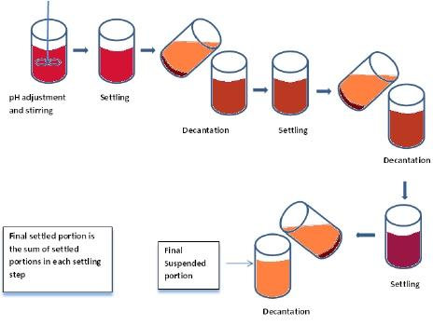

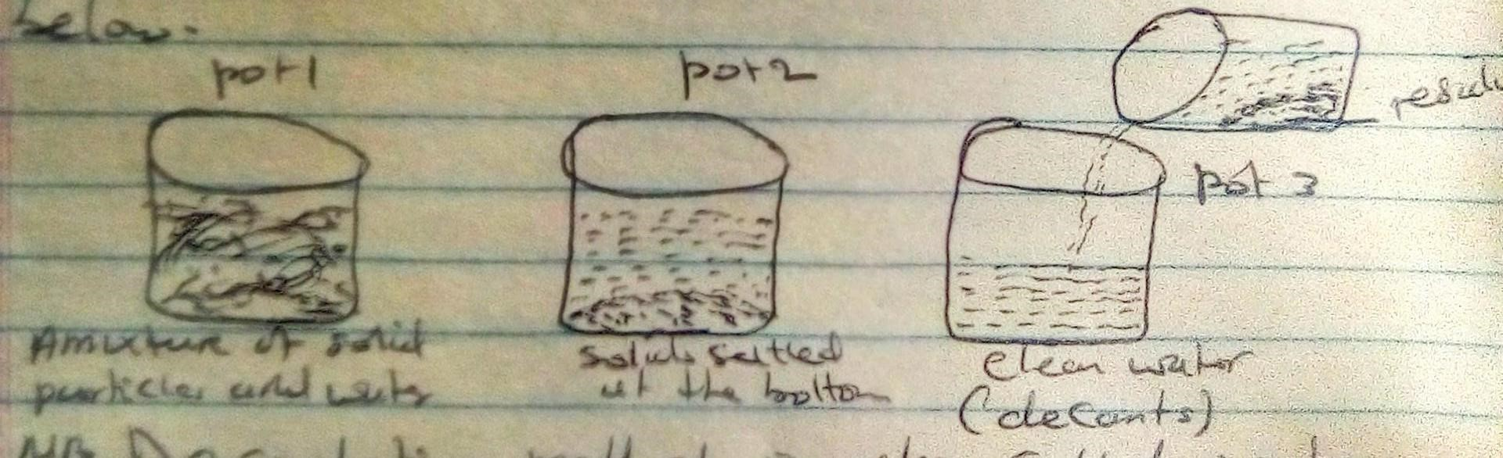

**NB.** Decantation method is also called water **purification**

1. Water got by decantation is clean but not good/safe for drinking because it is still contains germs
2. This water can only be made safe by **boiling it** or **treating** it using recommended chemicals.

**Filtration**

This is the process of separating solid particles from liquids.

This process involves the use of a filter paper and a funnel.

The piece of paper should be folded into four equal parts and made in a cone shape

Filtration can be done using a sieve, cloth or even porcelain filter. **As shown below**

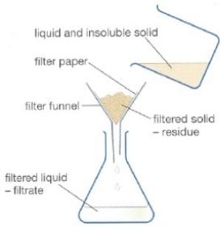Locally filtration is done using pebbles (stones), course of sand, fine sand, charcoal paste and cottonwood

The solid particles that remains on the filter is called **residues**

The clear water collected is called **filtrates**

Filtrates is clean water but not safe/good for drinking because is still contains germs.

It is made safe for drinking by **boiling** or **treating it** using recommended chemicals.

In our daily life/at home filtration is used when preparing **juice from fruits, separating tea leaves from tea, removing cream from rest of milk.**

**The three pot system of filtration**

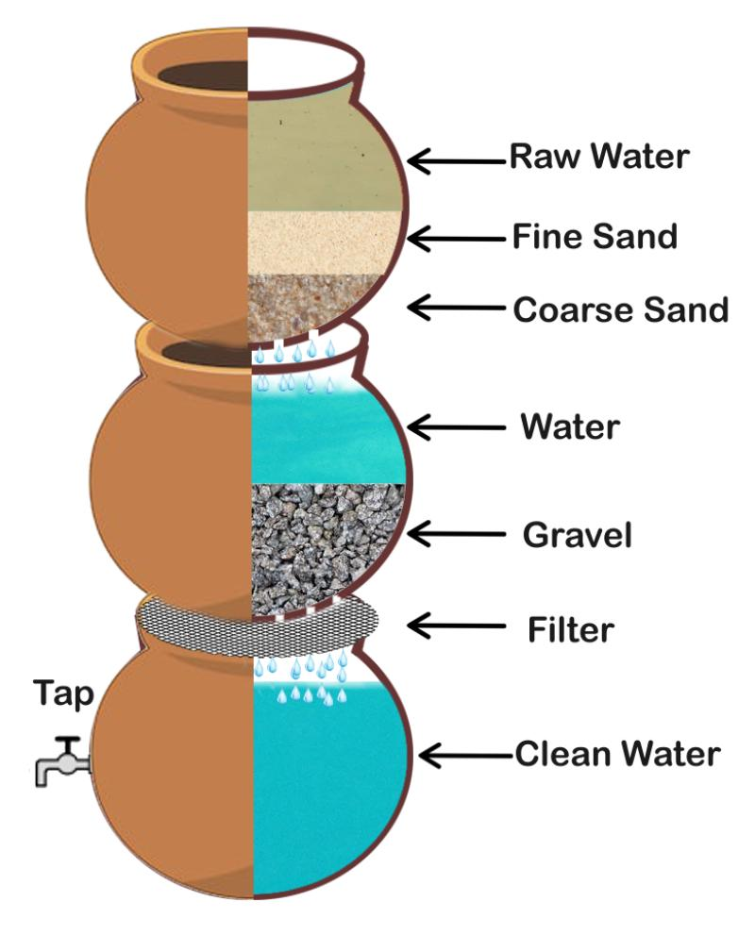**Distillation**

This is a process of obtaining pure water from impure water.

Muddy water is heated to evaporate and then condensing vapour given off to collect pure water.

The water/ liquid obtained by distillation is pure water/safe water

**Pure water :** Is water that hardly any impurities.

**Diagram showing distillation process**

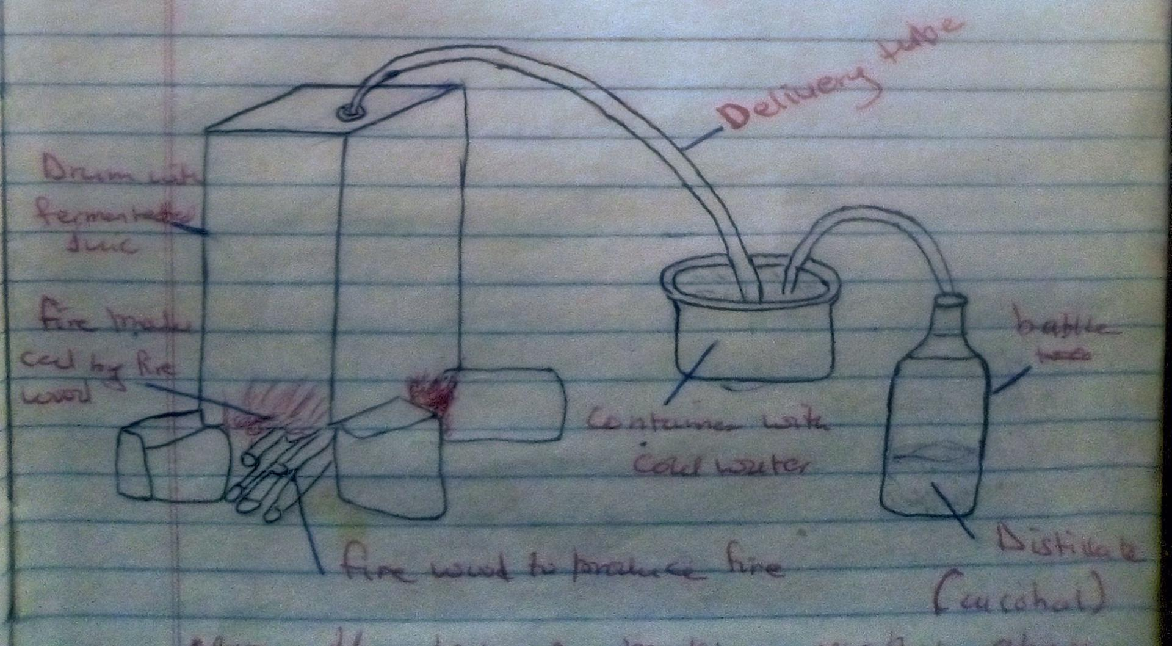**How distillation is done**

1. Dirty water is put into a heating container and then heated to evaporate.
2. The vapour is then collected by the delivery tube to the Cold water.
3. Cold water condenses the vapour back to liquid form and then collected.
4. The liquid obtained during distillation is called **distillate** (**distilled water** ).
5. Distilled water is not good for drinking because it does not contain mineral salts . And that is why it is poor conductors of electricity. **Examples of mineral salts contained in water;** calcium, sodium, fluoride, iron, potassium, magnesium and sulphate.
6. Distillation process involves two physical processes namely; **Evaporation** and  **condensations**

**Water impurities or water pollutants.**

**Water impurities** these are substances which when added into water change its natural qualify.

**Water pollution**  is the situation in which water become impure or spoilt when some substances get into it

The substances that makes water impure or spoilt are called **water pollutants. Examples of water pollutants;** human wastes, animal wastes, soil, chemicals, germs.

**How water can be pollute**

1. By the death and decomposition of organisms in water.
2. By deposition of non- biodegradable substances in water.
3. By leakage of petroleum products in transit.
4. By deposition of heavy metals in water bodies.
5. By silting.
6. By disposing human and 7animal wastes in water bodies (sewage).

**Non biodegradable substances:** These are substances that can not be broken down by bacteria and fungi. OR These are substances that can not decompose or rot. **Examples of non-biodegradable substances;** polyurethanes, plastics and glasses.

**Petroleum products and chemicals;** When these are poured into water they cover the water surface. This cut off oxygen supply to aquatic animals resulting into their death.

**Metals in water bodies;** There include **zinc, cobalt, aluminium and mercury.** These metals are toxic to aquatic life when get into water e.g. **aluminium is toxic to fish.**

**NOTE Sewage** are substances produced by human body and wastes from factories that are carried through sewers from houses and factories into water bodies.

**Sewers** are underground pipes used to carry sewage away from houses, industries, schools, hospitals.

**Silting:** Is the deposition of fine sand , clay or soil and other solid particles into water bodies

**Silts** is fine sand, soil, clay and other solid materials carried by running water into the water bodies.

**Water catchment ;** This is area where the water body gets its water from.

**Silting** is caused by captivation along riverbanks or lakeshores which leads to soil erosion.

**Effects of silting on water bodies.**

1. It reduces the depth of water bodies (make the water bodies sharrow
2. It leads to disappearance/dryness of water bodies
3. It leads to the flooding of surrounding area
4. It leads to death of aquatic organisms
5. It destroys habitat of aquatic life.

**Controlling of silting**

1. By controlling erosion.
2. Avoid cultivating around or near the riverbank
3. Protection of the registration cover around water bodies.

**Making salt from ash.**

Locally salt can be made from as by filtration process.

**Plant materials that can be used for making local salt are;** dry banana peeling, dry sweat potato peelings.

**Steps taken to obtain local salt from plants materials or ash.**

1. Collect dry plant materials use
2. Burn the dry plant materials collected to as
3. Collect the ash from the burnt plant materials and dissolve it in limited water.
4. Boil the solution to dryness (evaporation). The salt crystals will be seen at the bottom of source pan.

**Cleaning clothes in a home.**

At home one of the main use of water is to clean clothes.

**People need to clean clothes to prevent ;**

1. Parasites which live and breed in clothes.
2. Bad smell of clothes.
3. To look smart.

**Importance of clothes**

1. Clothing making us decent.
2. They make us smart.
3. They keep us worm.
4. They protect us from Cold and heat.
5. They protect us from injuries.

**NB;** *Clothes to be cleaned are called* ***laundry.*** *Washing, drying, ironing is called* **launder.**

**Steps used/ followed while cleaning clothes.**

***Sorting;*** This is selecting and putting clothes together according to their similarities in a particular way.

**Factors considered while sorting clothes for cleaning.**

1. The colour of the cloth.
2. The intensity of dirt.
3. The nature of the fabric.
4. Use of the Clothes.

***Soaking;*** This is the act of putting/sinking clothes in soapy water/ water with detergents for some time.

**Importance of soaking clothes**

1. It helps to loosen the dirt and dissolve stains.
2. 6 saves time during washing since less effort indeed to wash.
3. It helps to soften the cloth
4. Reduces tear and wear of cloth due to constant rubbing while washing.

soap (detergents)

***Washing;*** This is the act of squeezing and rubbing clothes using water and soap (detergents).

**Types of washing.**

***Hand washing;*** This is act of washing clothes using hands.

***Machine washing:*** This is the act of washing clothes using machines.

*Washing**removes**dirt**from**clothes****.***

***Rinsing;*** This is the removing lather/foam from washed clothes using clean water.

*It helps to remove all soapy water from the washed clothes.* If soapy water /lather is not removed will cause patches/ stains when cloth dries.

***Wringing***. This is the act of squeezing out excess water out of the Clothes.

*This is done to make clothes dry fast.*

**NB**. Woolen/cotton should be dried without wringing them because they may loosen the fabric and make them lose there shape.

***Drying***. This is the act of putting clothes in sunshine to dry or using a machine called ***drier***.

*This removes water from clothes and heat from the sun can kill weak germ.*

***Ironing.*** Ironing helps to kill germs in clothes.

*It helps to remove creases from washed Clothes and bring them to the original form.*